APIC Indiana
Recommended Guidance
for Hand Hygiene Measurement in Indiana

While this document focuses on the process of hand hygiene the ultimate aim is to reduce harm from preventable healthcare acquired infections.

These are recommended guidelines and resources to assist healthcare facilities in Indiana to adopt best practices with hand hygiene measurement. These guidelines should be tailored to your facility and can be used during annual planning of improvement activities that are driven by the risk assessment process.
This is an evolving document that will be tested within the various regions within Indiana.

As we continue to gain additional knowledge and learn best practices this document may be revised to continue to improve the measurement of hand hygiene in Indiana.

Background
Hand hygiene has long been recognized as the most important method to reduce the transmissions of organisms within healthcare facilities. Measuring adherence to hand hygiene is fundamental to demonstrating improvements at an organizational level. However, measuring hand hygiene is a very complex issue and many key factors should be taken into account when developing a measurement system.

According to CMS conditions of participation, healthcare facilities must determine which best practices standard will be used to guide their hand hygiene program. Regardless if the HICPAC Guidelines for Hand Hygiene in Healthcare Facilities or the World Health Organization guidelines are chosen, the basics of measurement follows similar evidence based principles.

APIC Indiana has recommended the following strategies for addressing hand hygiene measurement:
- Measurement
Determine what you will measure:
- Soap and water and/or alcohol based hand rub
- Report by discipline
- Report by weekday/weekend or shift

APIC Indiana recommends that measurement includes the 5 moments. It is documented in the research that it can be difficult to obtain opportunities beyond entry and exit; however including the moments beyond entry and exit when observed will provide critical information about hand hygiene performance. Accept that the majority of the observations will be on entry and exit. However, establishing a measurement system that captures the other moments/indications allows facilities to learn from those moments and understand hand hygiene at the most critical point in the process: prior to touching devices.

Measurement should reflect the hours of service. Therefore if you provide 24/7 service your observation data should be collected throughout those operational times.
Below we have included the moments/indications from WHO and an attachment is included to see how you can use these to measure beyond entry and exit.

World Health Organization (WHO) 5 Moments for Hand Hygiene:
Measure the 5 moments of hand hygiene that occur within the “patient zone”. The 5 moments are:
1) Before patient contact
2) Before aseptic task
3) After body fluid exposure
4) After patient contact with patient when leaving the patient zone
5) After contact with patient surroundings when leaving the patient zone.

Patient Zone, Healthcare area and Critical Sites:
To apply the 5 moments, it is critical you understand these 3 terms. The 5 moments occur when you are moving between the patient zone and the healthcare zone (moments 1, 4, 5) or between critical sites within the patient zone (moments 2, 3).

Patient Zone: Consists of the patient and his/her immediate surroundings. This typically includes the intact skin of the patient and all inanimate surfaces that are touched by or in direct physician contact with the patients such as bed rails, bedside table, bed linen and other medical equipment frequently touched by healthcare workers hands during the process of care (monitors, knobs and buttons and other high touch surfaces). This model assumes these items are contaminated with the same organisms as the patient’s intact skin. This model assumes that all equipment is cleaned between patients.

Healthcare area: All surfaces outside of the patient zone.

Critical Sites: These sites are associated with infection risk. These sites can either correspond to a body site or medical devices that need to be protected against microorganisms that can lead to infection or body sites that can lead to an exposure to the healthcare worker. The critical sites are address in moments 2 and 3.

Reference: WHO Guidelines on Hand Hygiene in Healthcare (2009)
Attachment: WHO 5 Moments

- Data Collectors
Everyone that participates in formal measurement system should be trained.
Training should include:
  - All the moments/indications including with the measurement program
  - Remaining anonymous during observations
  - Methods for random sampling
  - How to complete measurement form.
Assessment of knowledge following training is an important component of achieving reliable data.

Resources:
WHO and CDC data Collection Forms
iScrub lite application for iphone, ipad and droid

- Sample Size
Estimated total opportunities: To calculate your sample size, you need to estimate your total hand hygiene opportunities. Calculating this data at least annually will help you interpret your data by understanding your sample size. This can also be used to engage your observers to increase their number of observations.

Attachment: Estimating Hand Hygiene Opportunities Worksheet

Minimum Sample: The larger the sample the more reliable the data. The number of observations should be based on bed size and the estimated number of hand hygiene opportunities. Each facility should evaluate their current practice, infection rates, and total opportunities.

While sample size is important and the greater the sample sizes the more reliable the data. The Joint Commission provides the following guidance on sample size:
Population size of < 30 = sample 100% of available cases
Population size of 30-100 = sample 30 cases
Population size of 101-500 = sample 50 cases
Population size of > 500 = sample 70 cases
Reference: Hospital Accreditation Standards 2012. Accreditation Process ACC-70.

- Continuous Improvement of Measurement System
Performing an annual assessment of your measurement system and the reliability of data is essential. Set goals to incrementally increase your sample size annually. Consistent ongoing reporting of 100% compliance should be critically evaluated and process improvement with the measurement system should be considered. Since the ultimate aim is to minimize healthcare acquired infections comparing your hand hygiene performance to your trended data will be essential in this process.

5 Moments of Hand Hygiene
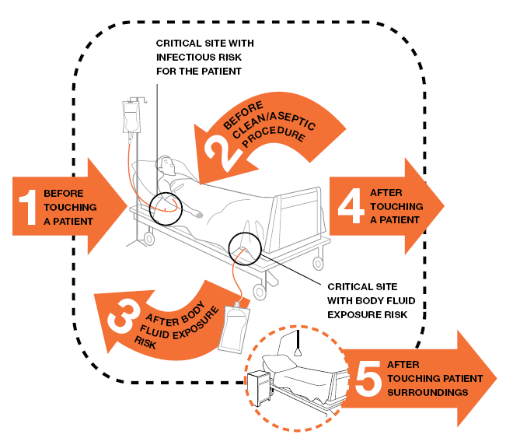

Examples of the patient zone include:
- Half of a semiprivate room dedicated to that patient
- One patient area in a open unit like a PACU or ED
- The immediate area surrounding a patient in an OR suite

Examples of patient zones:
- Half of a semi private room that is dedicated to that patient
- All of a private room
- The immediate area surrounding a patient in an open unit (PACU or ED)
- The immediate area surrounding a patient in the operative suite (not entire suite)

Reference: World Health Organization

Estimating Hand Hygiene Opportunities Worksheet
Formula for Calculating Estimated Total Number of Hand Hygiene Opportunities

Total number of ICU beds
Multiply by 12 (estimated number of opportunities)
Multiply by 24 (# of hours in the day)
Multiply by 30 (# of days in the month)
This formula is designed to assist with determining your total estimated hand hygiene opportunities during a month. While there is no required sample size, the greater your sample size the more valid your data. Some hospitals have used this data to help explain why they need to increase the sample size and then annually they track their percentage.
Equals estimated number of ICU opportunities:___________
Number of opportunities currently observed: __________
Total number of med/surg beds

Multiply by 6 (estimated number of opportunities)
Multiply by 24 (# of hours in the day)
Multiply by 30 (# of days in the month)
Equals the estimated number of Med/Surg opportunities:___________
Number of opportunities currently observed: __________
Future Goal: _____________
Total number of Ancillary patients per hour

Multiply by 3 (estimated number of opportunities)
Multiply by # of hours open per day
Multiply by # of days open per month
Equals the estimated number of Ancillary opportunities:_______________
Number of opportunities currently observed: __________
Add all 3 numbers together to get the total number of opportunities:_______________
Number of opportunities currently observed: __________
Future Goal: _____________
Reference: Measuring Hand Hygiene Adherence: Overcoming the Challenges, Joint Commission, 2009

Measurement Tools
Sample Data Collection Forms  Choose and then amend the form that  meet your needs. | Note there is a free app iScrub Lite that is a hand hygiene data collection tool that exports the data to excel once it is entered into the app.
Sample Educational Materials

Sample Handouts

Sample Hand Hygiene Data Collection Form

